

Tensile Testing Machine 2.0

Table of Contents

1.MENU PAGE 2

2.TESTING 3

**Tensile Testing:** 3

**Compress Testing:** 5

**Tare Testing:** 7

**Flexural Testing:** 8

3.SPECIMEN 9

**ADD** 9

4.UTM MANUAL CONTROL: 9

5.REPORTS: 11

6.SETTING 15

7.SOFTWARE DEVICE: 17

8.CONTROLER DEVICE: 18

# 1.MENU PAGE

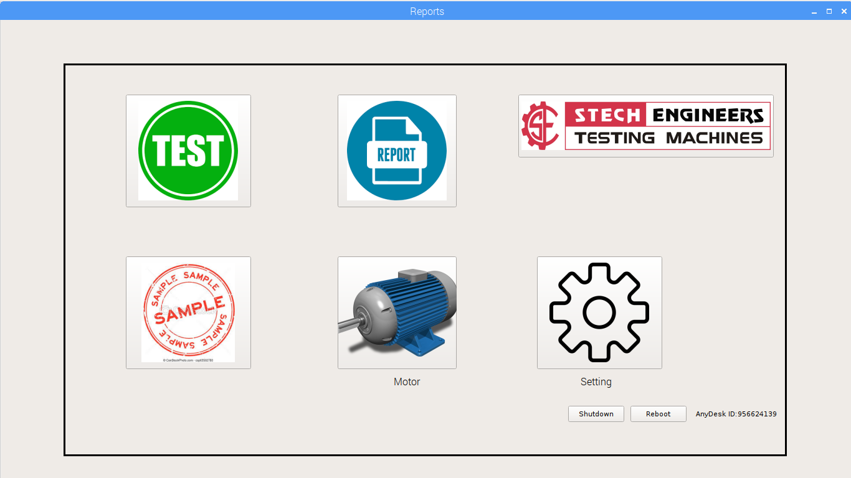

# 2.TESTING

# 

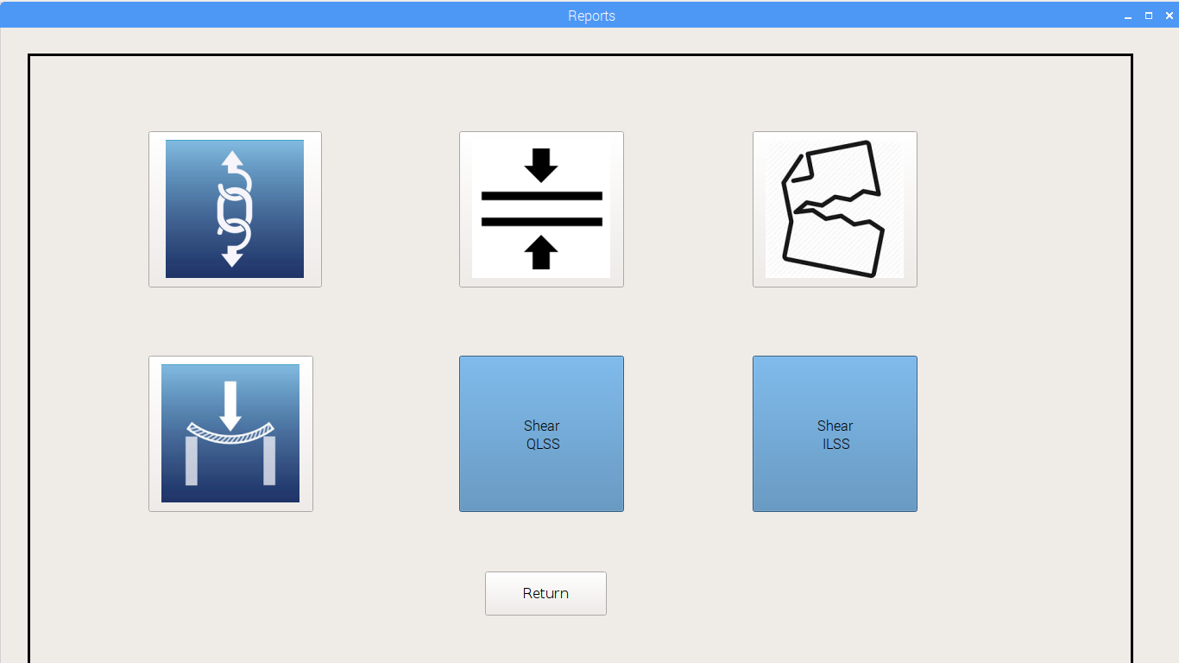

# Tensile Testing:

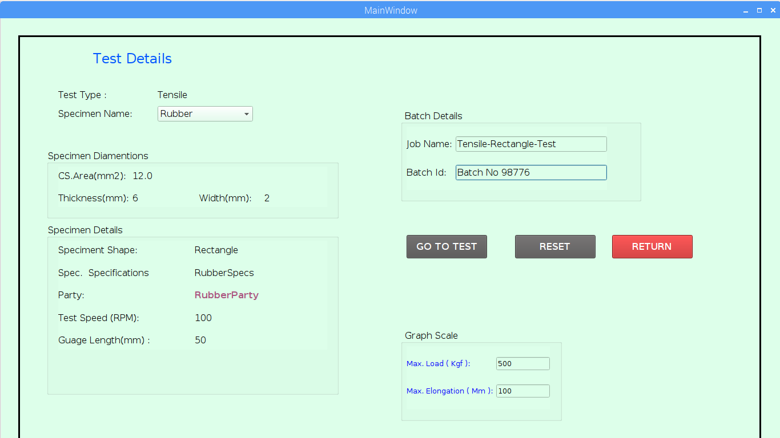

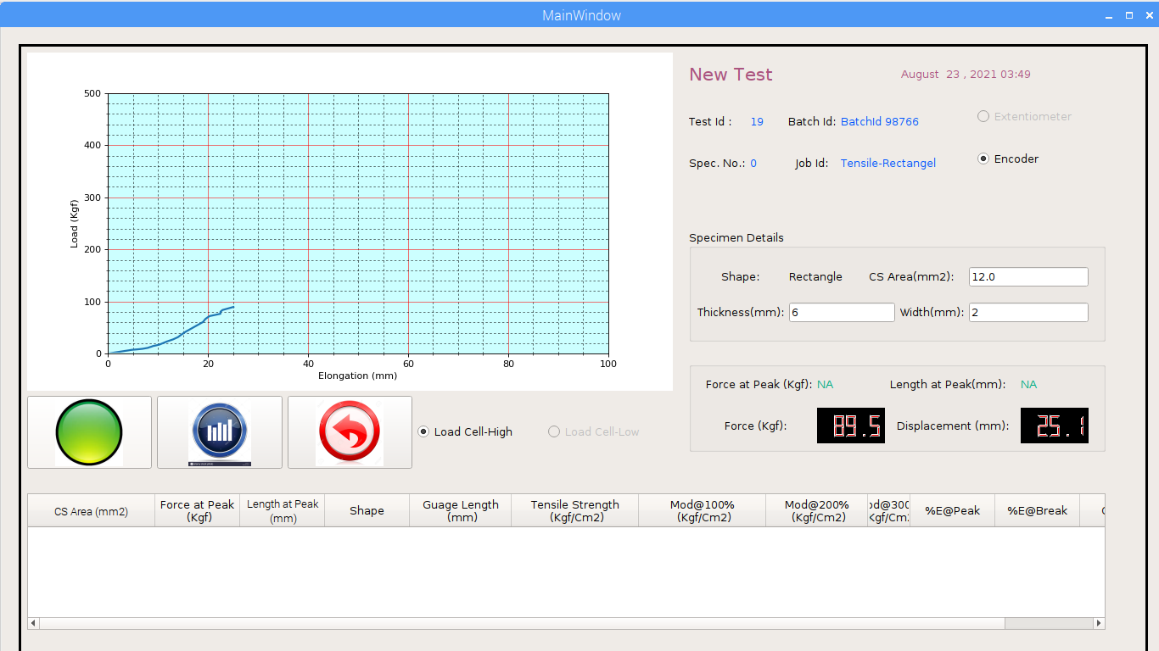

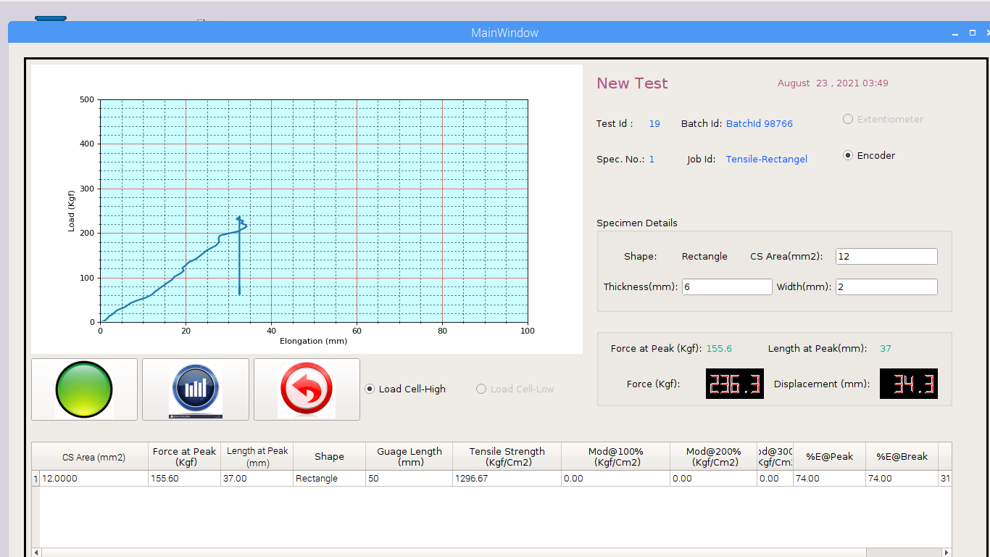

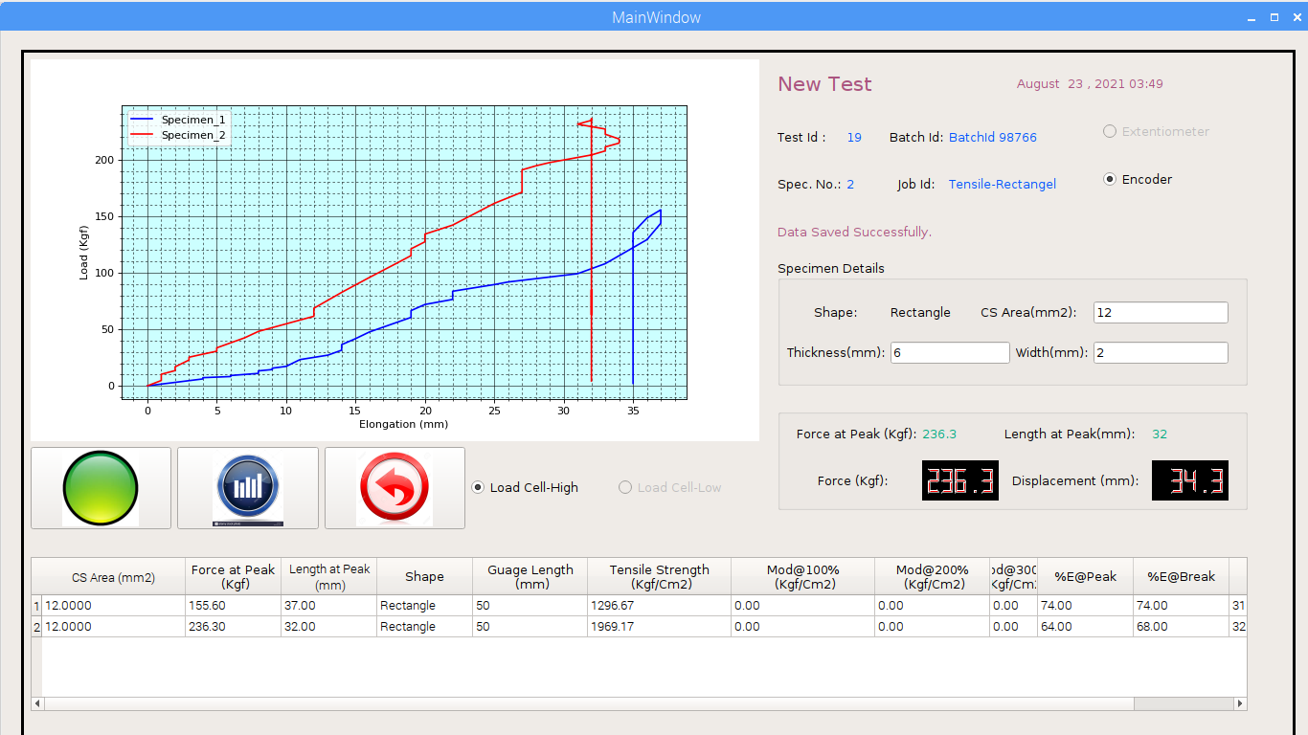

# Compress Testing:

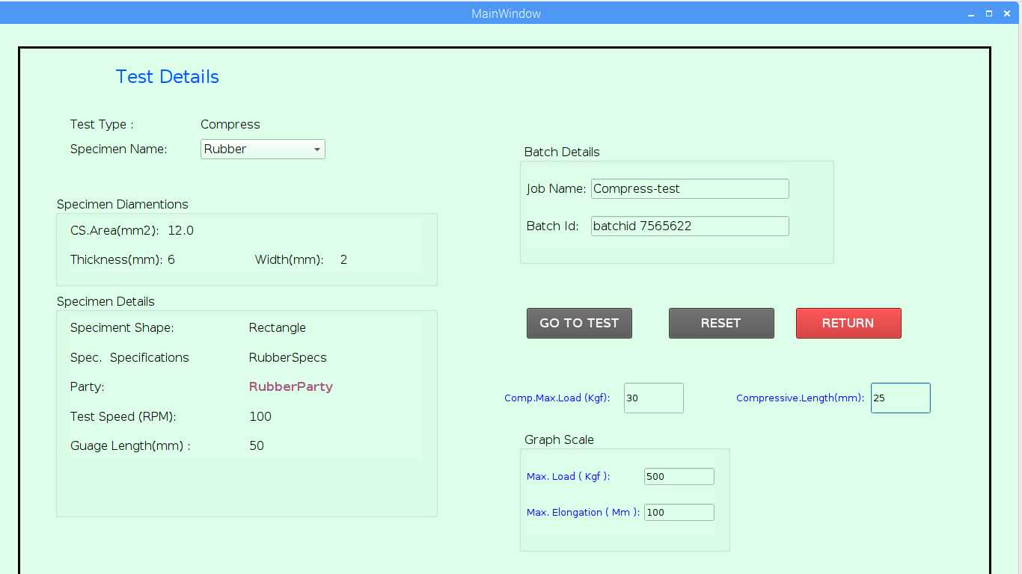

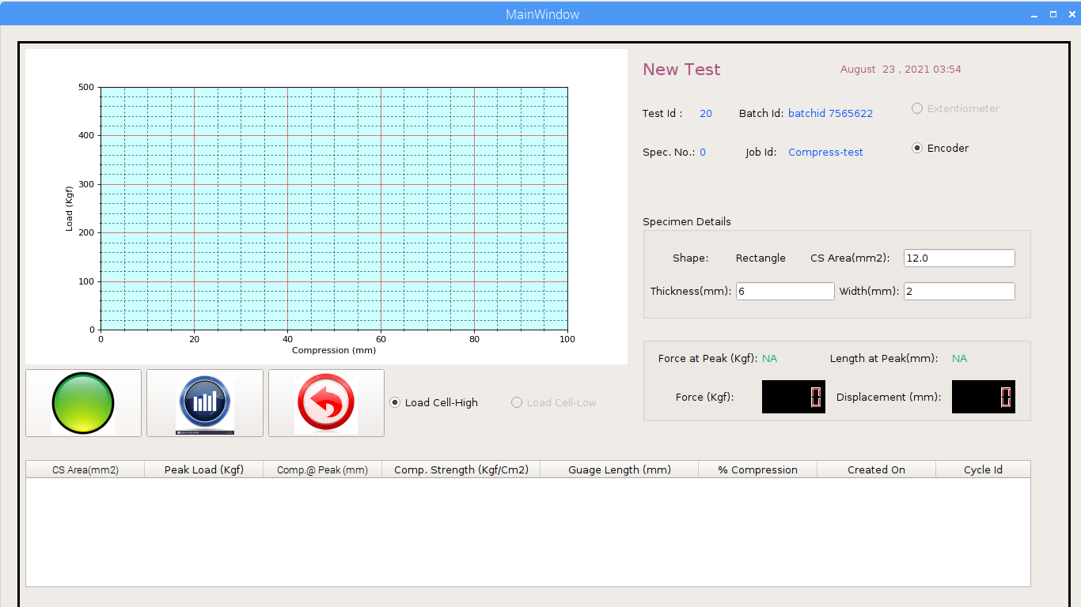

# Tare Testing:

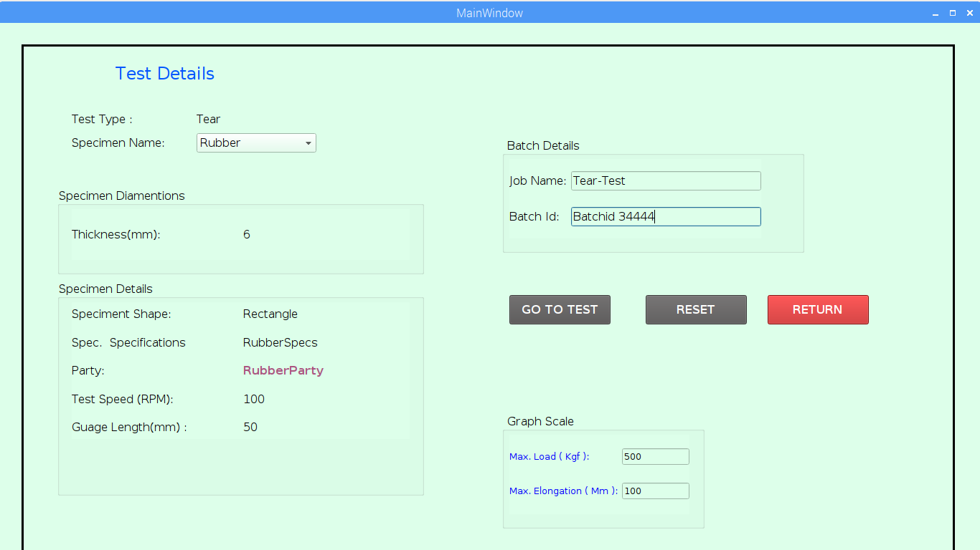

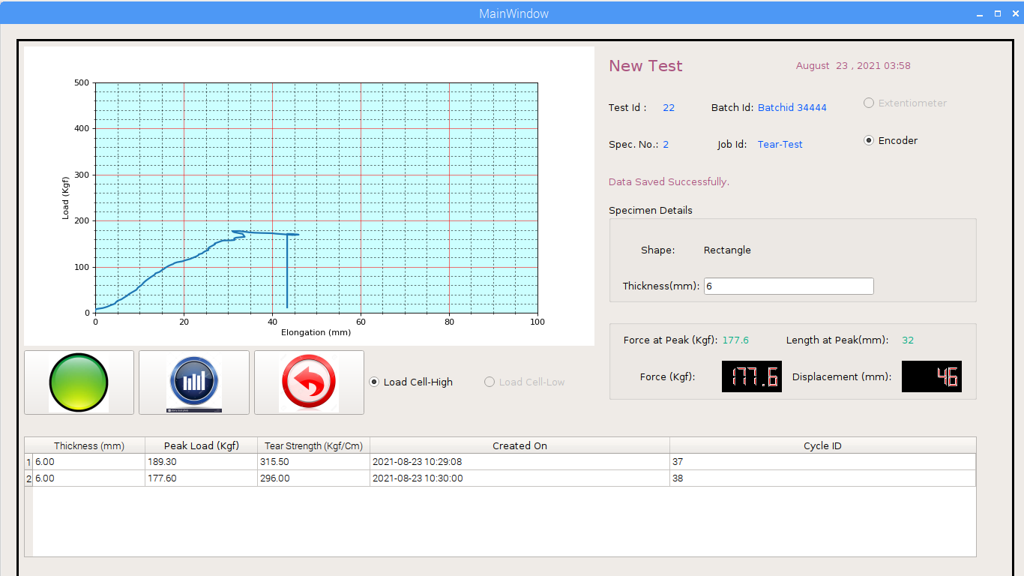

# Flexural Testing:

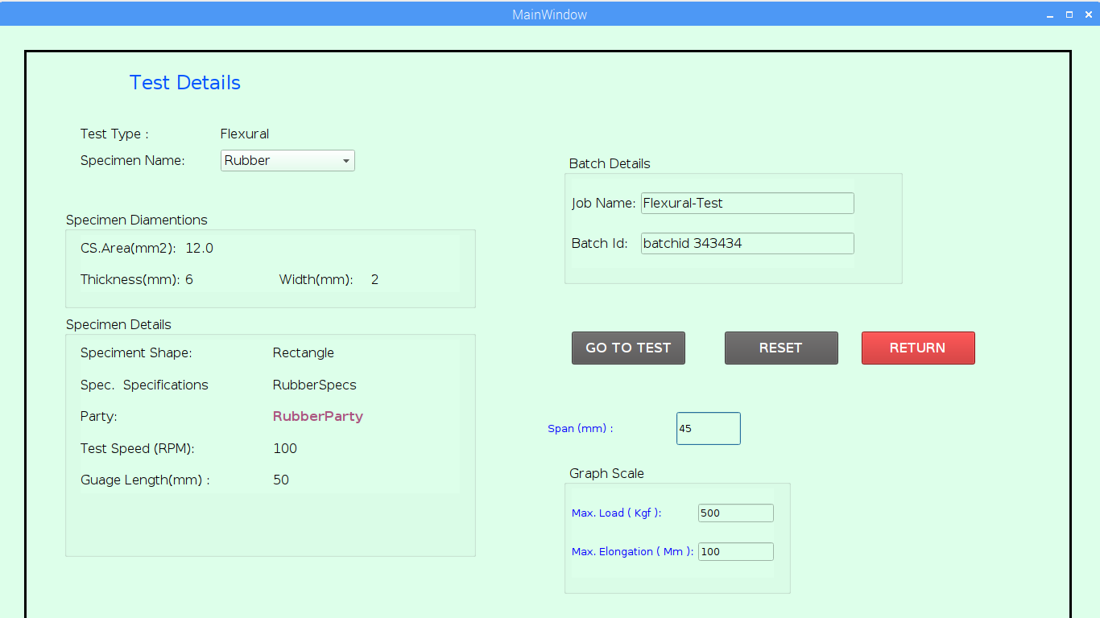

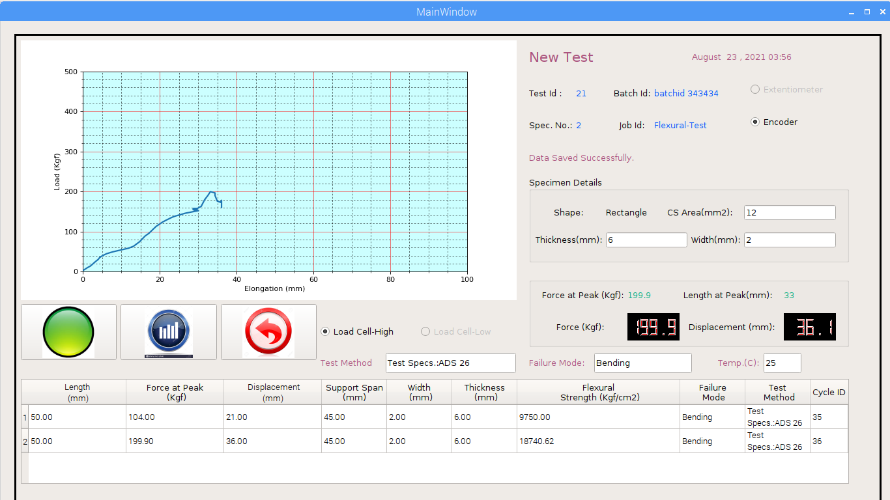

# 3.SPECIMEN

# ADD

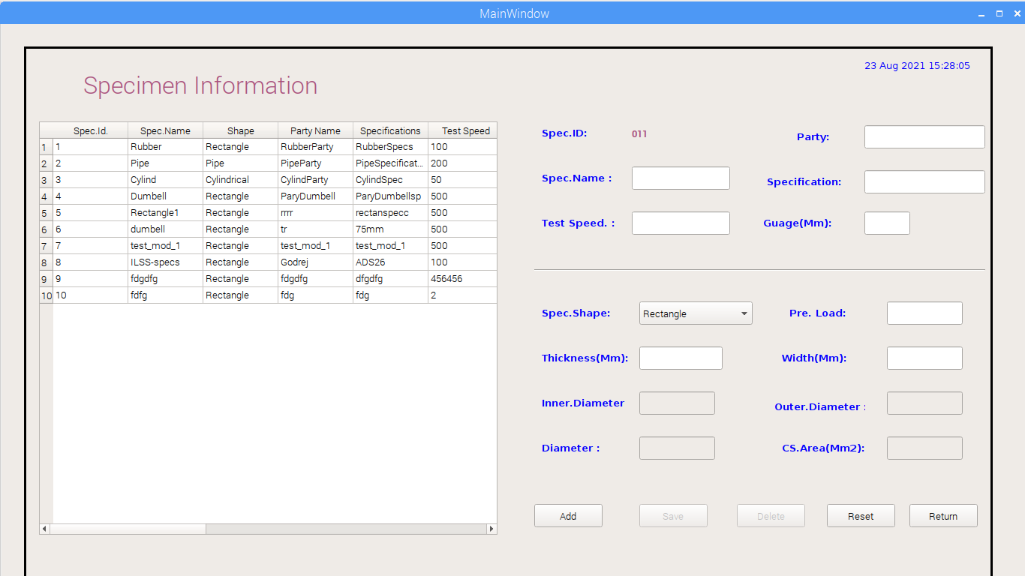

# 4.UTM MANUAL CONTROL:

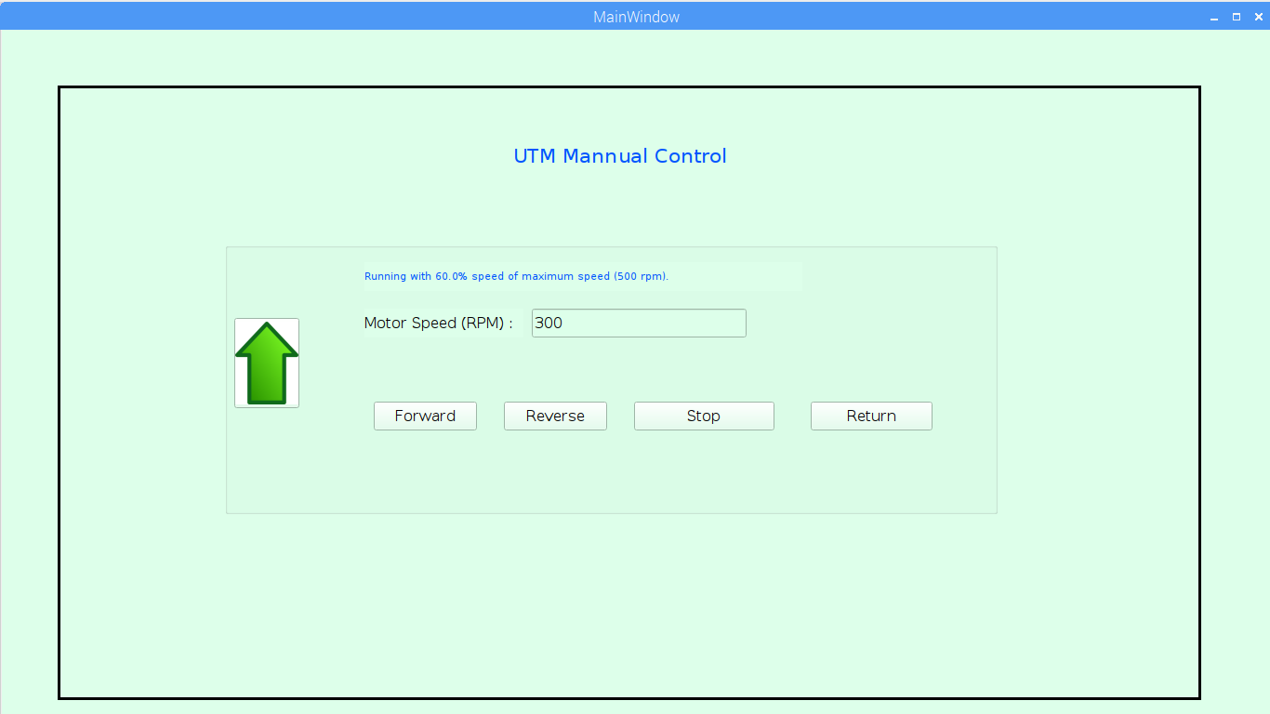

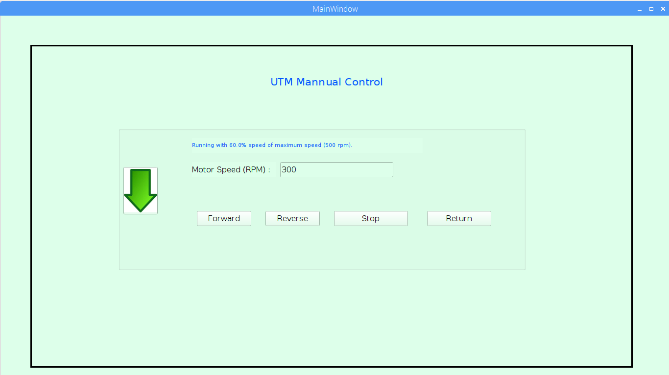

# 5.REPORTS:

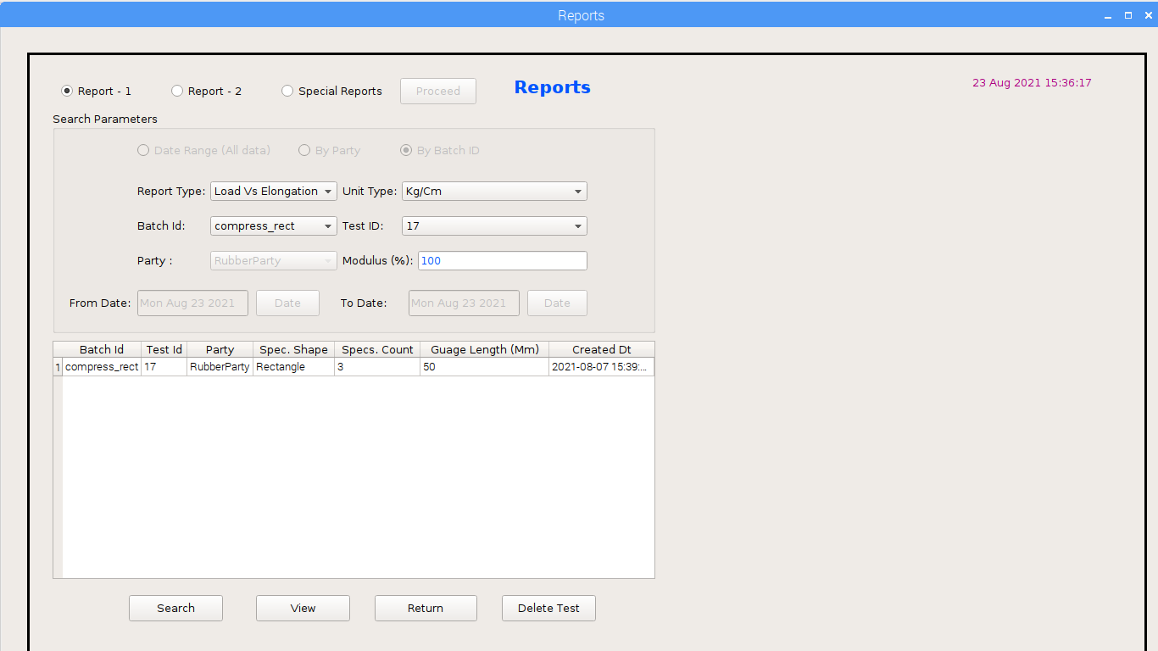

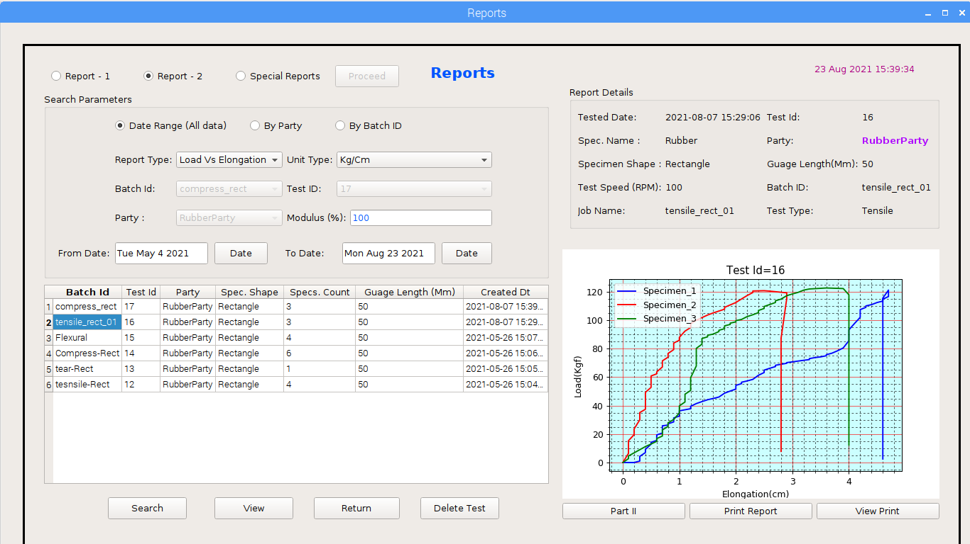

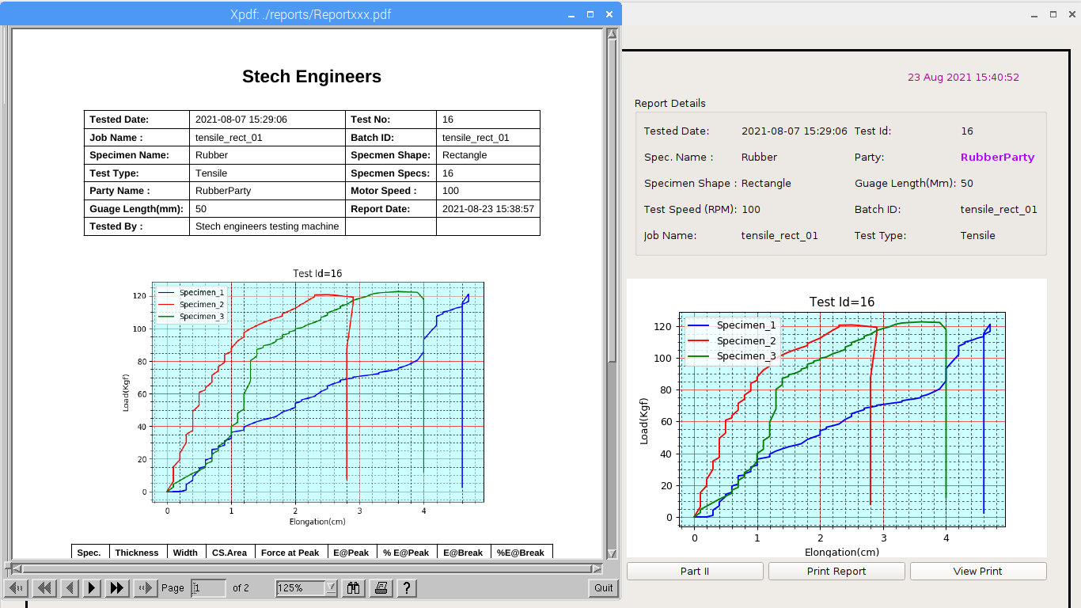

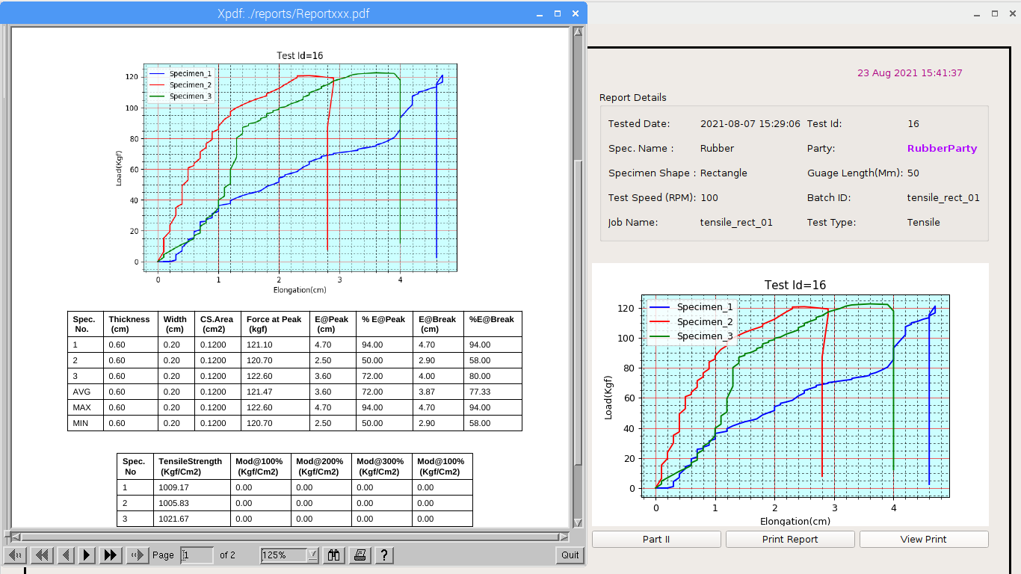

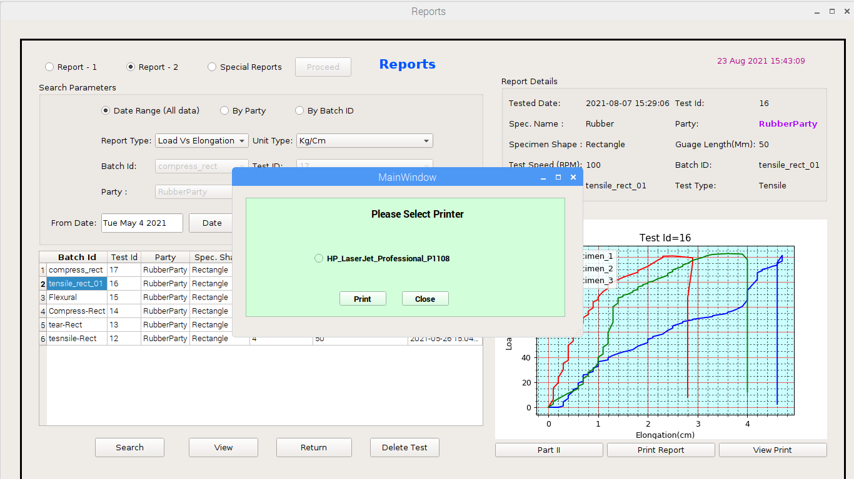

# 

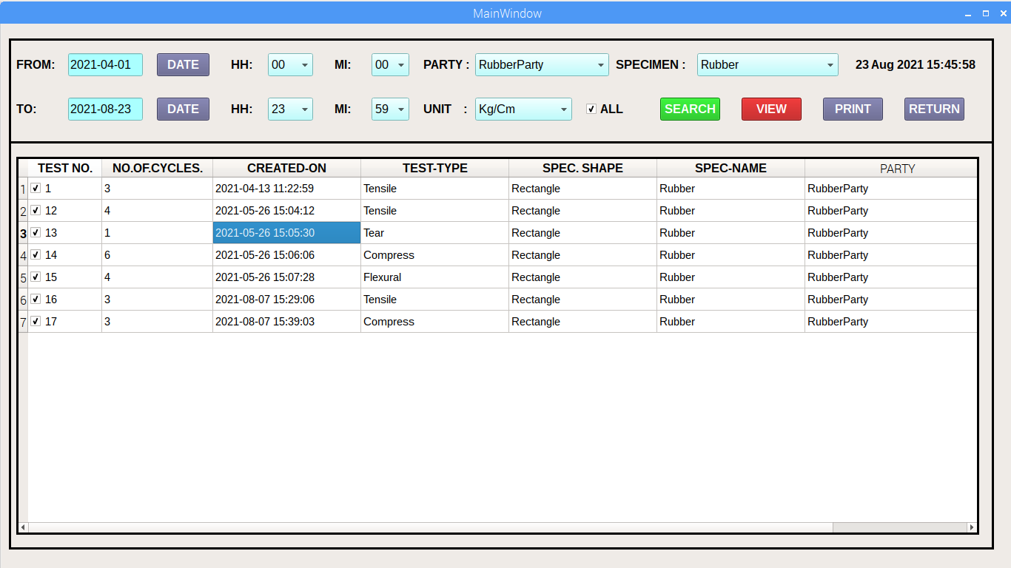

# 

# 6.SETTING

# 

# 

# 7.SOFTWARE DEVICE:

# 

Cost: 25,000/- Rs

# 8.CONTROLER DEVICE:

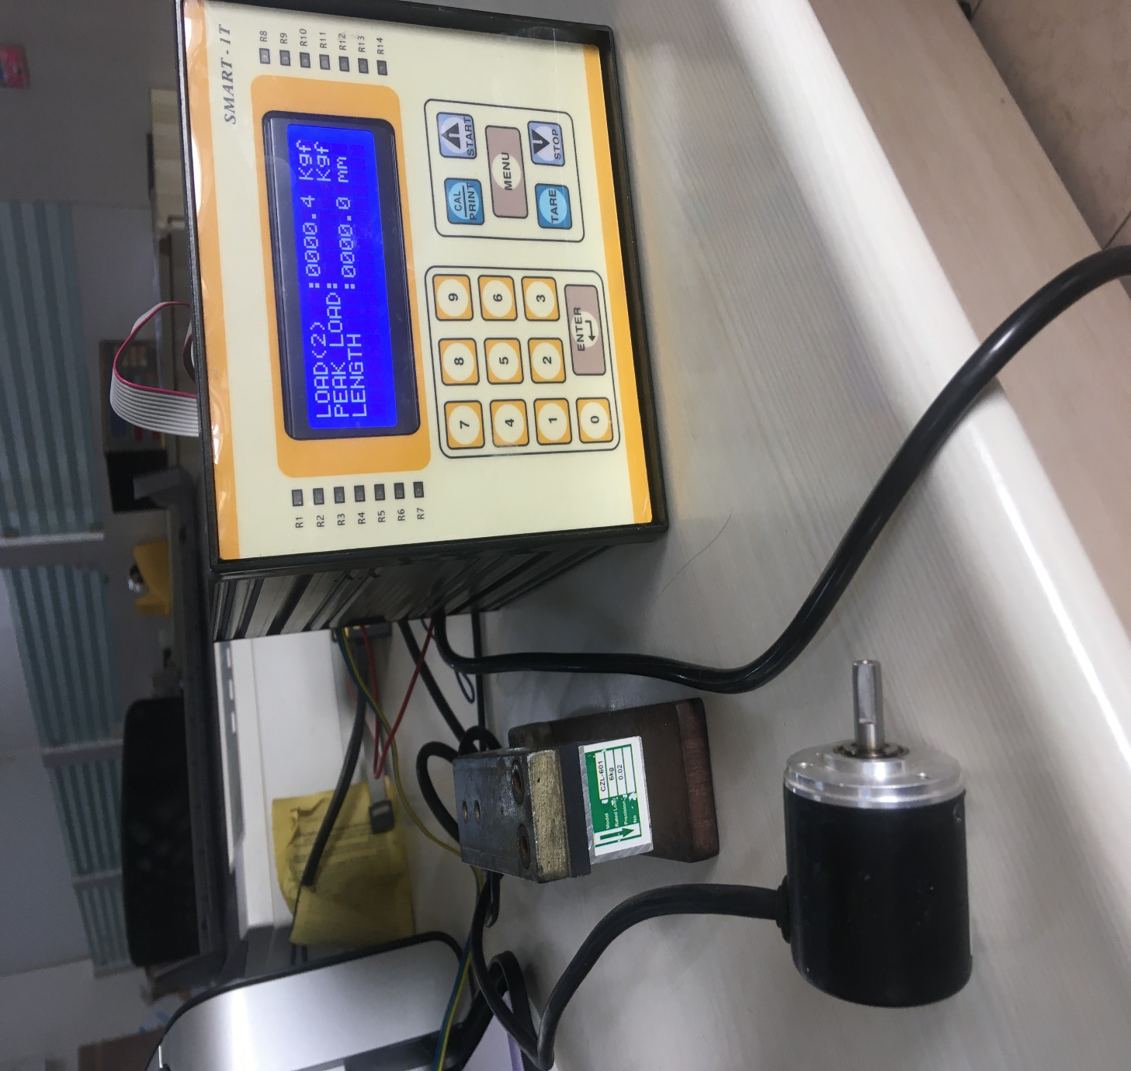

Cost: 20,000/- Rs

**Contact: Sanjay Mane - 9773540255**